So I’m Registered for Two Sentinels…Now What?!
CONFIRMATION
PACKET 2015
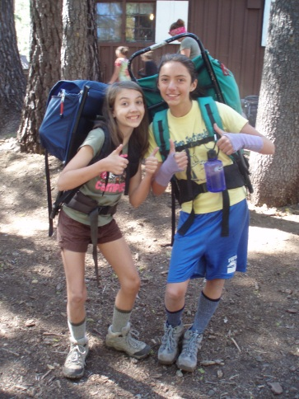
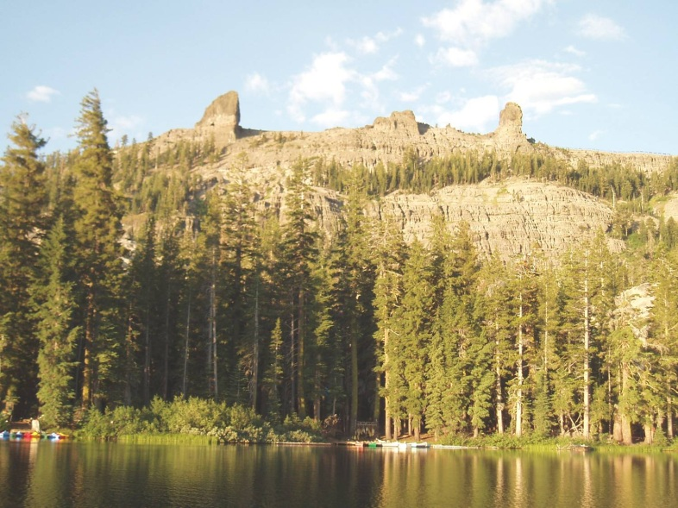
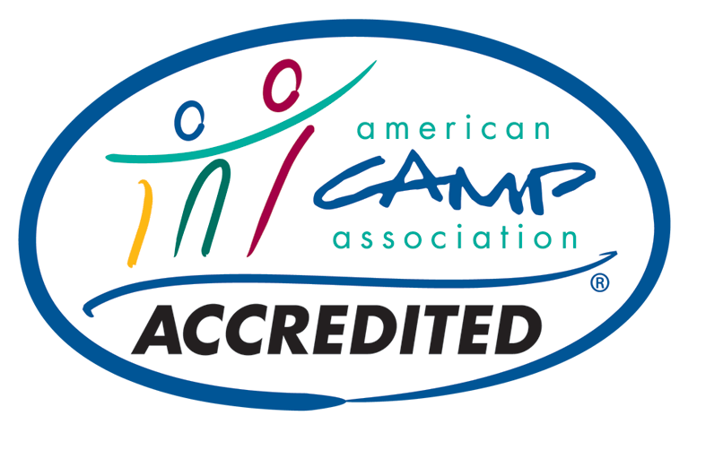
- CONGRATULATIONS! Your registration is CONFIRMED!
- Please read through this entire packet now…it includes lots of information and advice, links to online resources, and answers to many of the questions you may have about Two Sentinels and attending a resident camp.
- Please pay close attention to the paperwork you will need to send to us. This paperwork may be mailed OR scanned and emailed to us – unfortunately, we cannot accept faxes.
- If you have any questions, please feel free to contact us at any time!
TWO SENTINELS GS CAMP (916)873-3099 www.twosentinels.org admin@camptwosentinels.org
ONLINE RESOURCES
www.twosentinels.org
www.campparents.org

INTERESTED IN BECOMING A VOLUNTEER?

CONTACT US for more information, or come chat with us at the Faire! We’re always on the lookout for energetic volunteers interested in joining the Two Sentinels Family!

We have a TAG unit for staff children 5-12, boys and girls!
Volunteers may register their children beginning JANUARY 1.
Staff attend camp and all trainings free of charge!

THINGS WE OFTEN FORGET…
- CHAPSTIK! Please, please send at least two tubes or tins of lip balm with your daughter! Tubes are cleaner and work better at camp. This year you CANNOT rely on us to provide chapstik as we have in the past…this is NOT an optional item!
- My friend is scheduled for a different bus stop! That’s ok! You may change your bus stop any time before June 1, but please note that BOTH busses go to BOTH bus stops…so even if you get on the bus in Pleasanton and your friend gets on in Concord, you can still ride to camp together! Changes made after June 1 are subject to a $50 late fee, so make your arrangements early!
- I want to see camp before my daughter attends! GREAT! Come to our family work party in July! More info will be sent to the email address we have on file for you.
- Is it too late for a friend to attend? Possibly…have her register NOW if she’s interested, as most unit spots are filled within days of registration opening. However, we do everything we can to get friends into camp…so definitely have her register for a waiting list!
ATTENDING CAMP ALONE?
That’s ok! Many girls attend Two Sentinels without a friend…if your daughter is especially nervous, let us know…we’re working on a way for you to connect with other campers and parents online BEFORE camp begins! In the meantime, please let us know if you have any specific concerns.

2015 DATES

Session 1
July 19-26

Session 2
July 29 –Aug 5

Session 3
August 8-15

PAYMENT and HEALTH FORM DEADLINE

May 1, 2015

NEW! COUNTDOWN TO CAMP FAIRE!

April 19, 2015
2:30-4:30pm
Info in this packet!

CHECK US OUT

www.twosentinels.org

Two Sentinels is accredited by the
American Camp Association

REMINDER! Two Sentinels is at an elevation of 8000 feet. The weather can be very warm during the day, but cold at night, and temperatures may drop to freezing…rain is likely and snow is possible! Please equip yourself accordingly.
CAMPER EQUIPMENT CHECK LIST

LABEL ABSOLUTELY EVERYTHING with first and last name! Pre-printed labels are available here, and Two Sentinels receives 20 percent of all proceeds: www.emilypress.com/twosentinels.

www
LUGGAGE: Anything soft-sided that your camper can carry to her unit unaided is acceptable. Sleeping bag, sleeping pad, and extra blanket should be combined in a separate stuff sack or bag. Bring framed backpacks ONLY if you are backpacking!

DO NOT PACK IN BLACK GARBAGE BAGS! THEY MAY BE THROWN AWAY! Remember…it is better to pack in two or three small duffel bags rather than one extra large duffel bag…don’t forget to label the OUTSIDE of your duffel bags, too!

PACKS and SACKS |  |  |  | PERSONAL HEALTH—UNSCENTED ONLY, SMALL SIZES
___ | day pack |  |  | ___ | comb/brush
___ | Meadowlarks only: mesh dunk bag for mess kit |  |  | ___ | hair ties/bands/pins/barrettes
 | Optional—Nice to Have |  |  | ___ | nail clippers
 | ___ | hip pack—aka fanny pack or lumbar pack |  | ___ | nail file
 | ___ | laundry bag |  | ___ | contact lens supplies
 | ___ | several one-gallon resealable plastic bags |  | ___ | spare contact lenses/glasses
SLEEPING GEAR |  |  |  | ___ | sun screen—SPF 30 or above; no aerosol cans
___ | ground cloth—durable plastic, minimum size 4 by 6 feet |  |  | ___ | insect repellent—up to 30% deet; no aerosol cans
___ | insulating pad—minimum length from shoulder to hip, |  |  | ___ | deodorant/antiperspirant
 | one inch thick; this is for warmth, not just comfort |  |  | ___ | menstrual supplies—be prepared for the unexpected
___ | sleeping bag—rated for 20 degrees F or lower |  |  | ___ | small mirror
___ | warm blanket |  |  | ___ | tissues
 | Optional—Nice to Have |  |  | ___ | wash cloth
 | ___ | pillow case—stuff with clothes for pillow |  | ___ | bath towel
 | ___ | lovey—stuffed animal, blankie, etc. |  | ___ | beach towel
 | ___ | extra sleeping bag—necessary for bedwetters! |  | ___ | prescription medication—over-the-counter meds available at camp
EATING and DRINKING GEAR |  |  |  | CLOTHING
___ | one-quart (one-liter) plastic water bottle with screw-on lid |  |  | Head and Face
 | or canteen |  |  | ___ | hat with brim
___ | Meadowlarks only: mess kit—bowl, cup with handle, fork, spoon |  |  | ___ | cap for warmth—fleece or wool
ESSENTIAL GEAR |  |  |  | ___ | 2 or more bandanas
___ | whistle |  |  |  | Optional—Nice to Have
___ | 1–2 sources of light—flashlights/lanterns/headlamps |  |  |  | ___ |  | sunglasses—with UVA/UVB protection
___ | extra batteries and bulbs |  |  | Upper Body
OPTIONAL GEAR—Nice to Have |  |  |  | ___ | 2–5 bras
___ | watch—remember, no cell phones |  |  | ___ | 3–5 light-weight short-sleeved shirts
___ | sewing kit/safety pins |  |  | ___ | 3–5 light- and mid-weight long-sleeved shirts
___ | chemical hand/foot warmers |  |  | ___ | 2 heavy-weight long-sleeved sweaters or sweatshirts
___ | emergency space blanket |  |  | ___ | warm jacket
___ | camera—remember, no cell phones |  |  | ___ | waterproof jacket or poncho—with hood
___ | pencil/pen/permanent marker |  |  | ___ | pair gloves or mittens—fleece, polyester, or wool
___ | journal |  |  |  | Optional—Nice to Have
___ | stationery/postcards—preaddressed and stamped |  |  |  | ___ |  | vest or other layering piece
___ | fishing gear—license needed for ages 16 and older; |  |  | Lower Body
 | opportunity not guaranteed |  |  | ___ | 8 or more pairs underpants
___ | white shirt or pillow case to silkscreen—cotton or 50/50 |  |  | ___ | 3–4 pairs shorts or capris
 |  |  |  | ___ | 3–4 pairs pants
No Electronic Devices  phones, ipods, mp3/cd/dvd/game players, e-readers, tablets, etc.  No Food, Candy or Gum — No Pocketknives |  |  |  | ___ | 2 pairs pajamas or sweatpants or long underwear
 |  |  |  | ___ | swimsuit
 |  |  |  |  | Optional—Nice to Have
 |  |  |  |  | ___ | pair wind pants
PERSONAL HEALTH—UNSCENTED ONLY, SMALL SIZES |  |  |  |  | ___ | pair waterproof pants
___ | biodegradable soap |  |  | Feet
___ | moisturizing lotion/cream |  |  | ___ | 8 pairs socks
___ | toothbrush |  |  | ___ | 2 pairs hiking socks—wool
___ | toothpaste |  |  | ___ | 2 pairs sturdy shoes or boots—with laces
___ | 2 chap sticks |  |  | ___ | pair water shoes—closed toe, heel and sides
___ | shampoo |  |  |  | Optional—Nice to Have
___ | conditioner |  |  |  | ___ | pair boots for rain/snow/mud

NO ELECTRONIC DEVICES! No cell phones, kindles, dvd players, cd players, ipods, mp3 players, Gameboys, etc.

COUNTDOWN TO CAMP

___ Now! Make an appointment for a physical exam immediately, especially if you are on an HMO plan. Remember, physicals and physician’s signatures are now good for only 12 months, regardless of whether or not you attended camp in 2014. If you lose your form, a new one may be downloaded from our website at www.twosentinels.org, or through the CampDoc site (where you registered). Please call immediately if your health form will be delayed!

ALL CAMPERS MUST COMPLETE A NEW HEALTH FORM!

___ April Send signed medical forms and balance of fee by May 1 to:
Two Sentinels Girl Scout Camp P.O. Box 10906, Pleasanton, CA 94588
OR pay your balance online and submit your forms that way! It’s definitely the best way to do things!

___ April Attend the IN-TOWN INFORMATION FAIRE on SUNDAY, APRIL 19, 2015. An update with more information will be sent to you in March. This is the perfect time to turn in forms, pay balances, talk to staff and directors, get your equipment checked (for backpackers), and ask questions about paperwork, forms, bus schedules, equipment…anything! Registrations will NOT be accepted at this faire – it is only for campers who are already registered to attend Two Sentinels. THIS FAIRE SERVES AS THE REQUIRED IN-TOWN MEETING FOR TREKKERS AND SUPERPACKERS!

___ May Check equipment list. Call toll free (916)873-3099 or email admin@camptwosentinels.org if you have any questions. Try shopping at a second-hand store for camp clothes. You may send more clothes than listed. Remember, you will be hauling all your belongings from the dock to your unit!

___ June Borrow or buy needed items. Use duffel bags that you can carry in which to pack your clothes…two small duffels is MUCH better than one large one! Your sleeping bag and pad should be combined in another stuff sack or duffel bag, if possible. Bring framed backpacks only if you are backpacking. Remember, NO BLACK GARBAGE BAGS…they may get thrown away! LABEL EVERYTHING!

___ July You will receive your bus pass departure location in the mail by early July. Departure points are Concord (7:30am SHARP!) and Pleasanton (8:00am SHARP!) Practice rolling or stuffing your sleeping bag at home.

___ CAMP IS HERE! Pack your lunch and a drink. Do not bring extra food or money. There is nothing to buy at camp. LEAVE YOUR CELL PHONES AT HOME…they don’t work at camp and we do not take responsibility for anything that may happen to them! Camp is dirty…super dirty. Leave all your valuables at home where they’ll be safe!

___ BLAST OFF!! Meet us at the bus location. Please be on time! If you get car sick, take medication ½ hour before bus departure time.
Have your family write to you:
Camper's name & unit
Two Sentinels Girl Scout Camp
PO Box 295
Kirkwood, CA 95646

PARENTS! - Write early. Mail can be very, very slow!
Letters sent to the camp PO box in Pleasanton will NOT reach your camper!

A FEW WORDS ABOUT CARE PACKAGES…
Care packages may seem like a good idea to those left at home…but they are NOT a good idea at camp! Unfortunately, the post office in Kirkwood is not equipped to handle multiple care packages, and they’re inevitably returned to the post office in Pioneer, and then returned to YOU.

If your child forgets something, please call us instead of mailing something to camp! Aside from the fact that boxes wouldn’t reach us until camp is nearly over (if they reach us at all!), we can usually take care of just about any forgotten item issue…but do let us know! If there is an immediate need (prescription medications left at home, etc.), we would rather know by phone so that our staff may take care of whatever needs your child may have…

Camper’s Name:

____________________________

Session ______ Unit _________

IMPORTANT! PLEASE RETURN!
Please return by MAY 1 with health form and fees to:
TWO SENTINELS GIRL SCOUT CAMP
PO BOX 10906
PLEASANTON, CA 94588
OR
Scan and email to admin@camptwosentinels.org

Two Sentinels is accredited by the
American Camp Association

Dear Parent or Guardian,
Please help make your child's experience at Two Sentinels an exciting and rewarding one. Please talk to your child and answer these questions. This information is kept confidential and shared with only the camp director, camp nurse/doctor, and your child’s unit staff.

What does your child want to do at camp? Please list the 3 things most important to her.

1.__________________________________________________________________________________________________________

2.__________________________________________________________________________________________________________

3.__________________________________________________________________________________________________________

List 3 things that you, as a parent, would like your child to gain from camp.

1.__________________________________________________________________________________________________________

2.__________________________________________________________________________________________________________

3.__________________________________________________________________________________________________________

Please take the time and explain any recent changes in your family life of which your child is aware, such as: marriage in the family (parents or sibling), relative moving in or out, divorce, separation, moving (yourselves or close friend), death of a relative or friend, school grade retention. What effect have any of these changes had on your child? Do you have any other general concerns?

___________________________________________________________________________________________________________

___________________________________________________________________________________________________________

___________________________________________________________________________________________________________

___________________________________________________________________________________________________________

Does your child have any fears such as darkness, insects, heights, deep water, etc? Please explain:

___________________________________________________________________________________________________________

___________________________________________________________________________________________________________

Please share anything else you feel would be important…the more we know, the better we may customize our program to serve your child! Additional information may be added on the back or emailed directly to the camp director at admin@camptwosentinels.org.

