So I’m Registered for Two Sentinels…Now What?!
CONFIRMATION
PACKET 2015
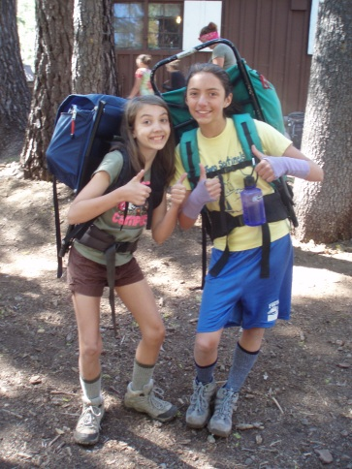
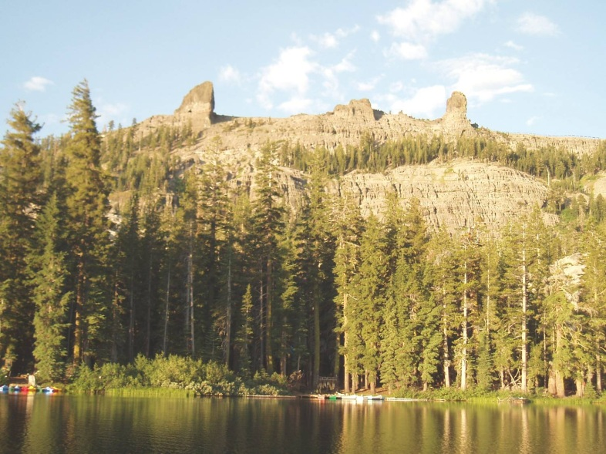
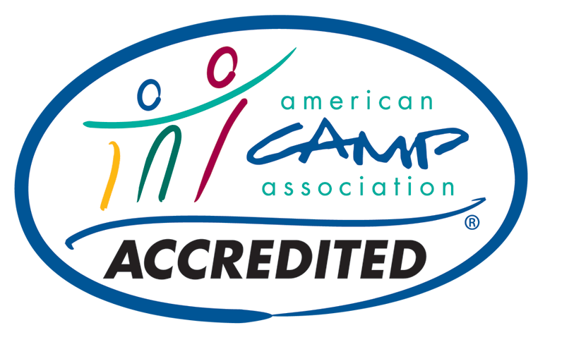
- CONGRATULATIONS! Your registration is CONFIRMED!
- Please read through this entire packet now…it includes lots of information and advice, links to online resources, and answers to many of the questions you may have about Two Sentinels and attending a resident camp.
- Please pay close attention to the paperwork you will need to send to us. This paperwork may be mailed OR scanned and emailed to us – unfortunately, we cannot accept faxes.
- If you have any questions, please feel free to contact us at any time!
TWO SENTINELS GS CAMP (916)873-3099 www.twosentinels.org admin@camptwosentinels.org
ONLINE RESOURCES
www.twosentinels.org
www.campparents.org

INTERESTED IN BECOMING A VOLUNTEER?

CONTACT US for more information, or come chat with us at the Faire! We’re always on the lookout for energetic volunteers interested in joining the Two Sentinels Family!

We have a TAG unit for staff children 5-12, boys and girls!
Volunteers may register their children beginning JANUARY 1.
Staff attend camp and all trainings free of charge!

THINGS WE OFTEN FORGET…
- CHAPSTIK! Please, please send at least two tubes or tins of lip balm with your daughter! Tubes are cleaner and work better at camp. This year you CANNOT rely on us to provide chapstik as we have in the past…this is NOT an optional item!
- My friend is scheduled for a different bus stop! That’s ok! You may change your bus stop any time before June 1, but please note that BOTH busses go to BOTH bus stops…so even if you get on the bus in Pleasanton and your friend gets on in Concord, you can still ride to camp together! Changes made after June 1 are subject to a $50 late fee, so make your arrangements early!
- I want to see camp before my daughter attends! GREAT! Come to our family work party in July! More info will be sent to the email address we have on file for you.
- Is it too late for a friend to attend? Possibly…have her register NOW if she’s interested, as most unit spots are filled within days of registration opening. However, we do everything we can to get friends into camp…so definitely have her register for a waiting list!
ATTENDING CAMP ALONE?
That’s ok! Many girls attend Two Sentinels without a friend…if your daughter is especially nervous, let us know…we’re working on a way for you to connect with other campers and parents online BEFORE camp begins! In the meantime, please let us know if you have any specific concerns.

2015 DATES

Session 1
July 19-26

Session 2
July 29 –Aug 5

Session 3
August 8-15

PAYMENT and HEALTH FORM DEADLINE

May 1, 2015

NEW! COUNTDOWN TO CAMP FAIRE!

April 19, 2015
2:30-4:30pm
Info in this packet!

CHECK US OUT

www.twosentinels.org

Two Sentinels is accredited by the
American Camp Association

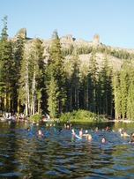

Dear Rover and Wanderer Parents/Guardians:

You have enrolled your daughter in the Two Sentinels backpacking program, no doubt wishing her a wonderful trip, a sense of accomplishment and many happy memories. We at Two Sentinels wish her the same and spend many hours in preparation to make it happen. Let us share with you some ways to ensure that your daughter’s backpacking experience will be a wonderful one.

First, and most important, HAVE YOUR DAUGHTER PROPERLY OUTFITTED! When you carry your entire camping “house” on your back, your equipment can make or break the trip. When choosing equipment and clothing, avoid bulky items. Remember that ½ of her pack will carry her share of food and cooking equipment.

A BACKPACK THAT FITS: Backpacks are very individual. They do not need to be expensive, but they do need to be comfortable. External frame packs are sometimes preferred for first-timers who are unsure about how often they will want to use the pack…but they’re difficult to find these days and not as comfortable as internal frame packs. A properly fitted internal frame pack (emphasis on the PROPERLY FITTED part!) will make her experience a more enjoyable one. If you are going to borrow an internal frame pack, please have it fitted to her in town by someone who knows what they’re doing. If you are buying or renting, insist that the store fit the pack before leaving. Be sure the pack has a comfortable, padded hip belt. After you get home, load the pack up with 25 pounds and have your daughter carry it 2 to 3 miles. If it seems heavy, fine. If it hurts, SOMETHING IS WRONG and it needs to be adjusted!

There are many other areas where you may skimp and save…but a poorly fitted backpack will ruin the trip for your child. We’ve found that while their prices may not be the lowest in town (although they do have some tremendous clearance sales several times a year), the fitters at REI are superb. Keep an open mind when you arrive, as they will know what size/style will fit your daughter best, and they do not work on commission so you will not be sold “more pack than you need.” Plus, if the pack doesn’t work after the “test” walk above, REI accepts returns/exhanges.

Finally, know that we do have some very nice packs at camp that have been donated over the years for use in our WANDERER program. If your daughter is a Wanderer or FIRST TIME ROVER, please let us know if you would be interested in using one of our external frame packs. There is no charge to borrow a pack, but we would like to know ahead of time how many packs we need to have ready! We will do our best to get it to you before camp begins, but occasionally girls will need to pack their belongings in duffel bags and we will give her the pack when she arrives at camp. Again, it is IMPERATIVE that you RESERVE THE PACK AHEAD OF TIME! Please call ASAP, as loaner packs are limited.

BOOTS: Preferably high top, flexible, broken in and water repellent. Put the boots on for that backpack shakedown described above. Be sure they are comfortable for uphill & down. Thin, ribless cotton, wool, or polypropylene socks should be worn under a pair of heavier wool or synthetic socks. Tennis shoes are NOT acceptable hiking shoes. POOR SHOES CAN RUIN THE TRIP FOR YOUR DAUGHTER! If you are looking to save money, a good option is to try on different boots by different manufacturers to decide what fits your daughter best…then check out Campmor (www.campmor.com) to see if they’re available to order online. You can often save up to 50% off the normal retail price this way, but the Campmor option only works if you know ahead of time what actually FITS. Hiking boot sizes are often very different from normal tennis shoe or casual shoe sizes…please be sure your daughter’s shoes fit properly.

Due to safety concerns, girls who arrive at camp without hiking boots might not be allowed on the trail! PLEASE, if you are concerned about the expense, be sure to call us ahead of time. We will work something out, but it is imperative that your daughter arrives at camp with hiking boots. Sometimes we can find gently used hiking boots for you to borrow, if finances prevent you from providing this for your camper and if we have enough notice. Please do call ahead of time!

SLEEPING GEAR & CLOTHING: At over 8000 ft. elevation, nights and some days can be COLD, even in August! Adequate sleeping gear means clothing that is completely dry (shirt and sweatpants, NO jeans). The sleeping bag must be in a water resistant stuff sack (NO plastic bags!) If the bag doesn’t compact and “stuff,” it is not warm enough for high altitude backpacking. Fleece and polypropylene are best for day/evening clothing. A sweatshirt is not sufficient.

BACKPACKING ITEMS: Start out by separating and packing the backpack items in the backpack. Small or “trial” size toothpaste, flashlight, comb or brush, soap, sunscreen, towel, etc. should be used. All regular size items add up to extra unnecessary weight. Regular size items may be brought for in-camp time.

You have also received an equipment list with your camper packet. There are duplications between the lists. There is no need to duplicate your equipment. You will take backpacking equipment from all the equipment you bring to camp.

Please read the Backpacking List carefully.

Call our backpacking consultant, Kathy Gallagher (Staar) if you have questions at (925)465-4135. Outfit your daughter carefully for her safety and her hiking comfort, and she’s well on her way to a wonderful backpacking experience!

CHECK OUT OUR NEW ILLUSTRATED BACKPACKING EQUIPMENT GUIDE, INCLUDED IN THIS PACKET!

You need to be able to carry one-fourth of your
body weight. In addition to your personal gear,
you will carry a share of your group’s food,
shelter, and equipment.

Be prepared, be practical, but be as light
as possible!

REMINDER: The four most important items for a
successful hiking trip are SHOES, BACKPACK,
SLEEPING BAG, and RAIN PROTECTION!
These must be in good condition and of
good quality.

SHOES
They must be hiking boots with ankle support, properly fitted, WELL BROKEN-IN, and water repellent. Thin, ribless wool or polypropylene socks should be worn under a pair of heavier wool or synthetic socks.

BACKPACK
It is obvious that this should be comfortable. To achieve comfort, be sure backpack is correctly fitted, adequate in size, and well-balanced on the hips. CAUTION…do not get an internal frame pack that is too large for you!

PONCHO
Sometimes the last thing we think about, but its value cannot be overrated! Be sure yours is light and strong, and check it before you come to camp…an old poncho may have developed holes along its creases. Holes = wet hiker!

SLEEPING BAG
A down- or synthetic-filled sleeping bag, weighing 2-4 pounds, and rated for extreme cold is best. A plastic ground cloth is ALWAYS needed, as well as an insulating pad that is long enough to reach shoulder to hip.

BACKPACKING EQUIPMENT LIST – Wanderers & Rovers
CONFUSED? See the illustrated guide, included below!

REMEMBER…There is no need to duplicate equipment listed on both the regular camper equipment list and this special backpacking equipment list!

PACKS and SACKS |  |  |  | PERSONAL HEALTH—UNSCENTED; 1/2 TO 2 OUNCE SIZES
___ | framed backpack with hip belt—minimum capacity of |  |  | ___ | biodegradable soap
 | 55 liters, well-balanced on the hips, and PROPERLY FITTED |  |  | ___ | moisturizing lotion/cream
___ | waterproof pack cover |  |  | ___ | toothbrush
 | OR backpack-style poncho—covers pack and hiker; |  |  | ___ | toothpaste
 | with hood, durable and light, check for leaks |  |  | ___ | chap stick
 | OR 2 heavy plastic 30-gallon garbage bags |  |  | ___ | comb/brush
___ | stuff sack for sleeping bag |  |  | ___ | hair ties/bands/pins/barrettes
___ | mesh dunk bag for eating gear |  |  | ___ | nail clippers
___ | 5 one-gallon resealable plastic bags |  |  | ___ | contact lens supplies
___ | 5 one-quart resealable plastic bags |  |  | ___ | spare contact lenses/glasses
 | Optional |  |  | ___ | sun screen—SPF 30 or above; no aerosol cans
 | ___ | stuff sacks and/or compression bags |  | ___ | insect repellent—up to 30% deet; no aerosol cans
 | ___ | 2 two-gallon resealable plastic bags |  | ___ | deodorant/antiperspirant
SLEEPING GEAR |  |  |  | ___ | menstrual supplies—be prepared for the unexpected
___ | ground cloth—durable plastic, minimum size 4 by 6 feet |  |  | ___ | moist towelettes
___ | insulating pad—minimum length shoulder to hip; |  |  | ___ | hand sanitizer
 | this is for warmth, not just comfort |  |  | ___ | blister prevention—moleskin, toe protectors, talc, etc.
___ | sleeping bag—rated for 20 degrees F or lower; weighing 2–5 lbs. |  |  | ___ | small thin towel
 | Optional |  |  | CLOTHING—AVOID COTTON
 | ___ | pillow case—stuff with clothes for pillow |  | Head and Face
 | ___ | light-weight sleeping bag liner |  | ___ | hat with brim
EATING and DRINKING GEAR |  |  |  | ___ | cap for warmth—fleece or wool
___ | 2 cups OR cup and bowl—cups with handles |  |  | ___ | 2 or more bandanas—the more, the better
___ | spoon OR spork |  |  | ___ | sunglasses—with UVA/UVB protection
___ | 2 one-quart (one-liter) wide mouth (two-inch diameter) |  |  | Upper Body
 | plastic water bottles with screw-on lids |  |  | ___ | bra
 | OR 1 one-quart (one-liter) wide mouth (two-inch diameter) |  |  | ___ | 2 light-weight short-sleeved shirts
 | plastic water bottle with screw-on lid and a 1–2 liter |  |  | ___ | light-weight long-sleeved shirt
 | bladder hydration system with drinking tube |  |  | ___ | heavy-weight long-sleeved shirt
ESSENTIAL GEAR |  |  |  | ___ | warm jacket—warm and light, like fleece
___ | whistle |  |  | ___ | waterproof jacket or backpack-style poncho—with hood
___ | small flashlight OR headlamp |  |  | ___ | pair gloves or mittens—fleece, polyester, or wool
___ | extra batteries |  |  |  | Optional
___ | duct tape—three feet, wrapped around pencil, bottle or trekking pole |  |  |  | ___ | light-weight vest or other layering piece
___ | watch—inexpensive; remember, no cell phones |  |  | Lower Body
___ | baseplate compass—inexpensive |  |  | ___ | 2–3 pair underpants
___ | emergency space blanket |  |  | ___ | pair mid- or heavy-weight long underwear—for sleep
OPTIONAL GEAR |  |  |  |  | and warmth
___ | trekking poles |  |  | ___ | pair light-weight shorts or capris
___ | chemical hand/foot warmers |  |  | ___ | pair hiking pants
___ | sewing kit/safety pins |  |  | ___ | swimsuit
___ | 25–50 feet of seven-strand cord |  |  |  | Optional
___ | small straps/bungee cords |  |  |  | ___ | pair wind pants
___ | camera—remember, no cell phones |  |  |  | ___ | pair waterproof pants
___ | pencil/pen/permanent marker |  |  | Feet
___ | journal |  |  | ___ | 2 pairs liner socks—polypropylene or silk
___ | stationery/postcards—preaddressed and stamped |  |  | ___ | 3 pair hiking socks—wool
___ | paperback book |  |  | ___ | pair hiking boots—PROPERLY FITTED with ankle support
___ | deck of cards |  |  |  | and water repellency, and WELL BROKEN-IN
___ | fishing gear—license needed for ages 16 and older; |  |  | ___ | pair water shoes—closed toe, heel and sides
 | opportunity not guaranteed |  |  |  | Optional
No Electronic Devices—No Food, Candy, or Gum—No Pocketknives |  |  |  |  | ___ | short gaiters
ILLUSTRATED BACKPACKING EQUIPMENT GUIDE

BACKPACKS
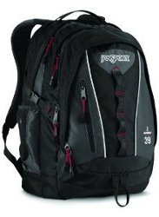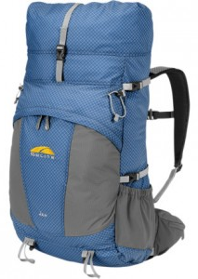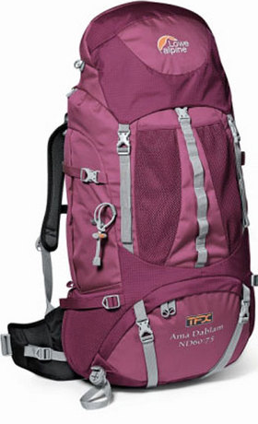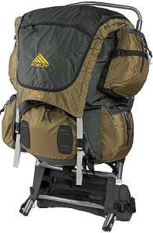
YES properly fitted external frame pack
YES properly fitted internal frame pack
NO frameless packs
NO daypacks

All packs MUST:
-have a padded hipbelt,
-have places to strap or stuff your sleeping bag (be sure it fits!),
-have a place to put and easily access your water bottles/hydration system.
-be large enough to fit your personal gear AND group gear for your trip length (under 50L is TOO small)

Ask an experienced fitter to help you choose and ADJUST your pack!

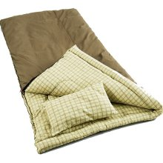
SLEEPING BAGS
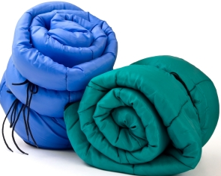
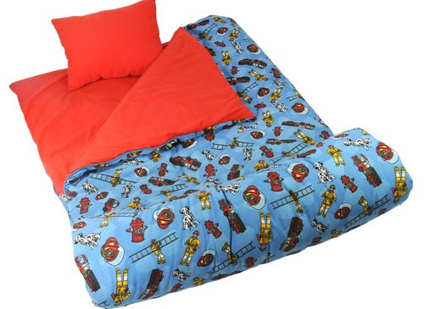
NO Coleman-type bags

NO roll-up bags
NO novelty bags

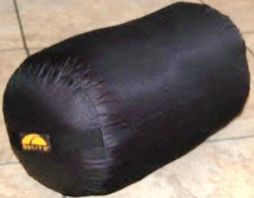

YES mummy bags
YES bag designed for a stuff sack
YES compression sacks for internal frame packs

All sleeping bags MUST:
- have a minimum of 20-25 Degree coldness rating
-be designed to utilize a stuff sack; NO ROLLUPS!
-be of appropriate size to the camper (not TOO small or TOO large)
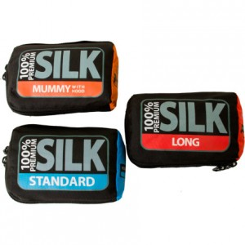
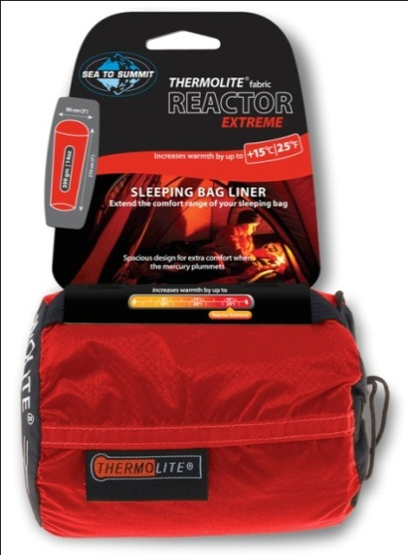
EXTRAS:
Cold camper? Want to keep your bag cleaner, longer? Try adding a sleeping bag liner, sometimes called a cocoon!

STORAGE TIP:
Once camp is done, store your sleeping bag outside of its stuff sack (flat, or in a large, loose sack). A bag stored while compressed will quickly lose its ability to keep you warm!

CAREFUL! Don’t ruin your bag! Read your bag’s instructions BEFORE washing in your washer!
WATER BOTTLES & HYDRATION
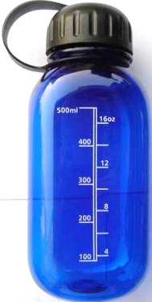
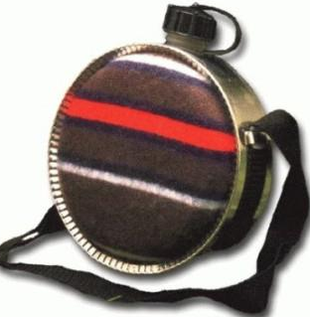
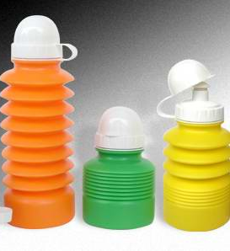

NO canteens
NO sport top water bottles- of ANY KIND
NO disposable bottles
NO smaller than ONE Liter

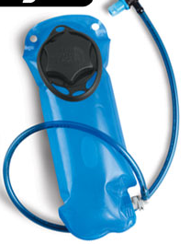
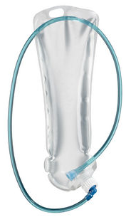
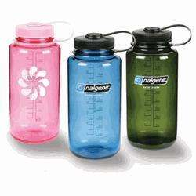

YES 1 Liter (+) hydration system
YES 1 Liter wide mouth bottle

Water is IMPORTATNT! All campers Must:
-have a minimum of (2) TWO 1 Liter bottles
-have at LEAST one widemouth bottle
-be of sturdy build to withstand falls on hard granite

Campers ONLY have two bottle style options:
OR
+
FOOT GEAR-WATER SHOES

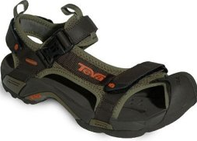
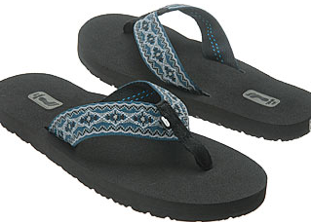
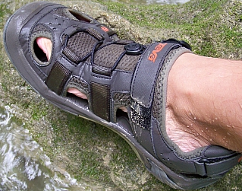
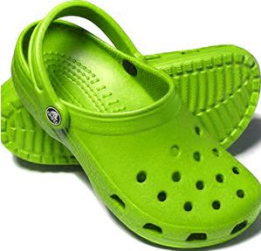

NO flipflops
NO gaps in the shoes
NO sandals, including sport
NO Crocs

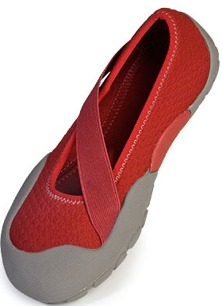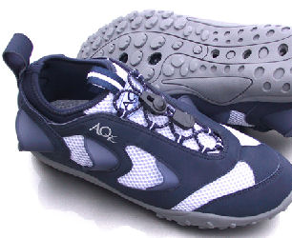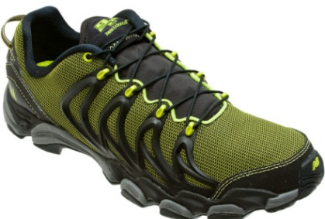

YES “water socks”
YES closed-toed & gap free aqueous shoes

All water shoes for camp AND backpacking MUST:
-have closed toes
-have closed heels
-have NO gaps in the shoe, including the sides

This is a SAFETY issue. Campers will not be allowed to wear inappropriate footwear.

FOOT GEAR-HIKING BOOTS & SOCKS

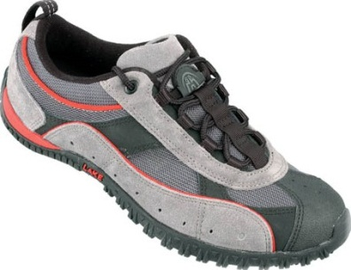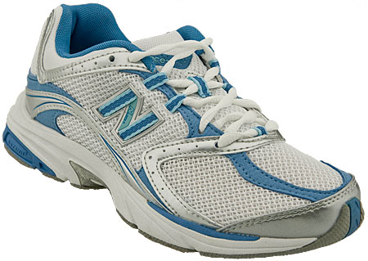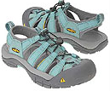
NO hiking sandals
NO running shoes
NO walking shoes
NO sneakers

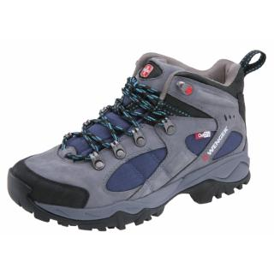
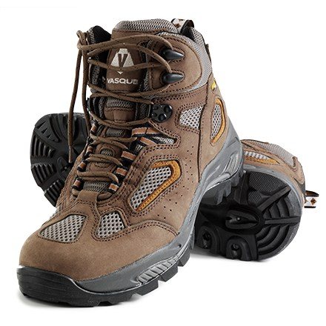
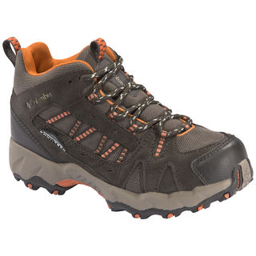
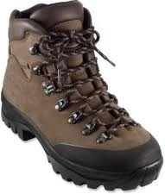
YES mid-height hiking boots; leather or synthetic

YES high top hiking boots; leather or synthetic

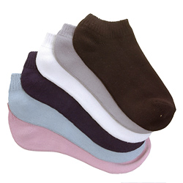
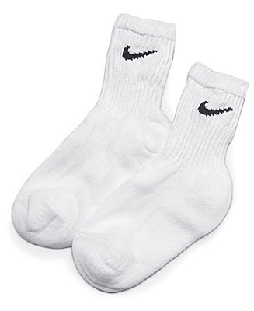

NO below ankle socks
NO cotton socks. PERIOD.

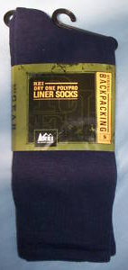
*Liner socks (2 pair) are STRONLY recommended, regardless of outer sock technology.
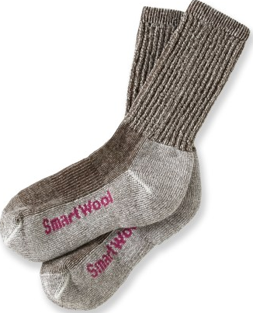
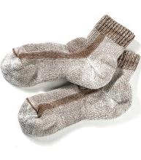

YES thin, synthetic/silk liner hiking socks
YES 2 pair thick smartwool (or similar) outer hiking socks
CLOTHING-BOTTOMS

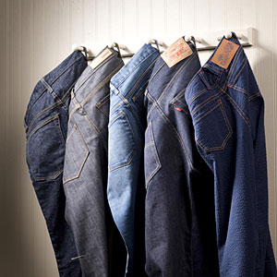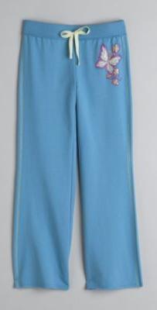
NO cotton sweatpants/exercise pants

NO jeans (ie. NO denim)

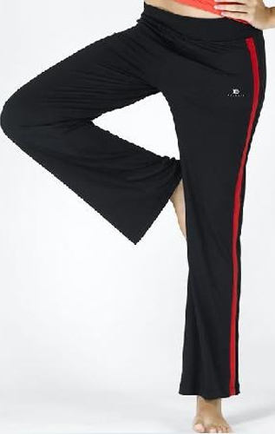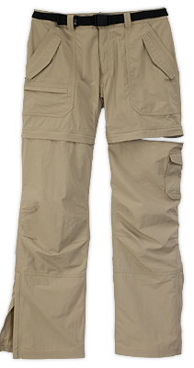

YES full length hiking pants or “zip-offs”; NO COTTON!

YES synthetic workout pants (running pants, yoga pants etc.); NO COTTON!

REMINDER! Two Sentinels is at an elevation of 8000 feet. The weather can be very warm during the day, but cold at night, and temperatures may drop to freezing…rain is likely and snow is possible! Please equip yourself accordingly.
CAMPER EQUIPMENT CHECK LIST

LABEL ABSOLUTELY EVERYTHING with first and last name! Pre-printed labels are available here, and Two Sentinels receives 20 percent of all proceeds: www.emilypress.com/twosentinels.

www
LUGGAGE: Anything soft-sided that your camper can carry to her unit unaided is acceptable. Sleeping bag, sleeping pad, and extra blanket should be combined in a separate stuff sack or bag. Bring framed backpacks ONLY if you are backpacking!

DO NOT PACK IN BLACK GARBAGE BAGS! THEY MAY BE THROWN AWAY! Remember…it is better to pack in two or three small duffel bags rather than one extra large duffel bag…don’t forget to label the OUTSIDE of your duffel bags, too!

PACKS and SACKS |  |  |  | PERSONAL HEALTH—UNSCENTED ONLY, SMALL SIZES
___ | day pack |  |  | ___ | comb/brush
___ | Meadowlarks only: mesh dunk bag for mess kit |  |  | ___ | hair ties/bands/pins/barrettes
 | Optional—Nice to Have |  |  | ___ | nail clippers
 | ___ | hip pack—aka fanny pack or lumbar pack |  | ___ | nail file
 | ___ | laundry bag |  | ___ | contact lens supplies
 | ___ | several one-gallon resealable plastic bags |  | ___ | spare contact lenses/glasses
SLEEPING GEAR |  |  |  | ___ | sun screen—SPF 30 or above; no aerosol cans
___ | ground cloth—durable plastic, minimum size 4 by 6 feet |  |  | ___ | insect repellent—up to 30% deet; no aerosol cans
___ | insulating pad—minimum length from shoulder to hip, |  |  | ___ | deodorant/antiperspirant
 | one inch thick; this is for warmth, not just comfort |  |  | ___ | menstrual supplies—be prepared for the unexpected
___ | sleeping bag—rated for 20 degrees F or lower |  |  | ___ | small mirror
___ | warm blanket |  |  | ___ | tissues
 | Optional—Nice to Have |  |  | ___ | wash cloth
 | ___ | pillow case—stuff with clothes for pillow |  | ___ | bath towel
 | ___ | lovey—stuffed animal, blankie, etc. |  | ___ | beach towel
 | ___ | extra sleeping bag—necessary for bedwetters! |  | ___ | prescription medication—over-the-counter meds available at camp
EATING and DRINKING GEAR |  |  |  | CLOTHING
___ | one-quart (one-liter) plastic water bottle with screw-on lid |  |  | Head and Face
 | or canteen |  |  | ___ | hat with brim
___ | Meadowlarks only: mess kit—bowl, cup with handle, fork, spoon |  |  | ___ | cap for warmth—fleece or wool
ESSENTIAL GEAR |  |  |  | ___ | 2 or more bandanas
___ | whistle |  |  |  | Optional—Nice to Have
___ | 1–2 sources of light—flashlights/lanterns/headlamps |  |  |  | ___ |  | sunglasses—with UVA/UVB protection
___ | extra batteries and bulbs |  |  | Upper Body
OPTIONAL GEAR—Nice to Have |  |  |  | ___ | 2–5 bras
___ | watch—remember, no cell phones |  |  | ___ | 3–5 light-weight short-sleeved shirts
___ | sewing kit/safety pins |  |  | ___ | 3–5 light- and mid-weight long-sleeved shirts
___ | chemical hand/foot warmers |  |  | ___ | 2 heavy-weight long-sleeved sweaters or sweatshirts
___ | emergency space blanket |  |  | ___ | warm jacket
___ | camera—remember, no cell phones |  |  | ___ | waterproof jacket or poncho—with hood
___ | pencil/pen/permanent marker |  |  | ___ | pair gloves or mittens—fleece, polyester, or wool
___ | journal |  |  |  | Optional—Nice to Have
___ | stationery/postcards—preaddressed and stamped |  |  |  | ___ |  | vest or other layering piece
___ | fishing gear—license needed for ages 16 and older; |  |  | Lower Body
 | opportunity not guaranteed |  |  | ___ | 8 or more pairs underpants
___ | white shirt or pillow case to silkscreen—cotton or 50/50 |  |  | ___ | 3–4 pairs shorts or capris
 |  |  |  | ___ | 3–4 pairs pants
No Electronic Devices  phones, ipods, mp3/cd/dvd/game players, e-readers, tablets, etc.  No Food, Candy or Gum — No Pocketknives |  |  |  | ___ | 2 pairs pajamas or sweatpants or long underwear
 |  |  |  | ___ | swimsuit
 |  |  |  |  | Optional—Nice to Have
 |  |  |  |  | ___ | pair wind pants
PERSONAL HEALTH—UNSCENTED ONLY, SMALL SIZES |  |  |  |  | ___ | pair waterproof pants
___ | biodegradable soap |  |  | Feet
___ | moisturizing lotion/cream |  |  | ___ | 8 pairs socks
___ | toothbrush |  |  | ___ | 2 pairs hiking socks—wool
___ | toothpaste |  |  | ___ | 2 pairs sturdy shoes or boots—with laces
___ | 2 chap sticks |  |  | ___ | pair water shoes—closed toe, heel and sides
___ | shampoo |  |  |  | Optional—Nice to Have
___ | conditioner |  |  |  | ___ | pair boots for rain/snow/mud

NO ELECTRONIC DEVICES! No cell phones, kindles, dvd players, cd players, ipods, mp3 players, Gameboys, etc.

COUNTDOWN TO CAMP

___ Now! Make an appointment for a physical exam immediately, especially if you are on an HMO plan. Remember, physicals and physician’s signatures are now good for only 12 months, regardless of whether or not you attended camp in 2014. If you lose your form, a new one may be downloaded from our website at www.twosentinels.org, or through the CampDoc site (where you registered). Please call immediately if your health form will be delayed!

ALL CAMPERS MUST COMPLETE A NEW HEALTH FORM!

___ April Send signed medical forms and balance of fee by May 1 to:
Two Sentinels Girl Scout Camp P.O. Box 10906, Pleasanton, CA 94588
OR pay your balance online and submit your forms that way! It’s definitely the best way to do things!

___ April Attend the IN-TOWN INFORMATION FAIRE on SUNDAY, APRIL 19, 2015. An update with more information will be sent to you in March. This is the perfect time to turn in forms, pay balances, talk to staff and directors, get your equipment checked (for backpackers), and ask questions about paperwork, forms, bus schedules, equipment…anything! Registrations will NOT be accepted at this faire – it is only for campers who are already registered to attend Two Sentinels. THIS FAIRE SERVES AS THE REQUIRED IN-TOWN MEETING FOR TREKKERS AND SUPERPACKERS!

___ May Check equipment list. Call toll free (916)873-3099 or email admin@camptwosentinels.org if you have any questions. Try shopping at a second-hand store for camp clothes. You may send more clothes than listed. Remember, you will be hauling all your belongings from the dock to your unit!

___ June Borrow or buy needed items. Use duffel bags that you can carry in which to pack your clothes…two small duffels is MUCH better than one large one! Your sleeping bag and pad should be combined in another stuff sack or duffel bag, if possible. Bring framed backpacks only if you are backpacking. Remember, NO BLACK GARBAGE BAGS…they may get thrown away! LABEL EVERYTHING!

___ July You will receive your bus pass departure location in the mail by early July. Departure points are Concord (7:30am SHARP!) and Pleasanton (8:00am SHARP!) Practice rolling or stuffing your sleeping bag at home.

___ CAMP IS HERE! Pack your lunch and a drink. Do not bring extra food or money. There is nothing to buy at camp. LEAVE YOUR CELL PHONES AT HOME…they don’t work at camp and we do not take responsibility for anything that may happen to them! Camp is dirty…super dirty. Leave all your valuables at home where they’ll be safe!

___ BLAST OFF!! Meet us at the bus location. Please be on time! If you get car sick, take medication ½ hour before bus departure time.
Have your family write to you:
Camper's name & unit
Two Sentinels Girl Scout Camp
PO Box 295
Kirkwood, CA 95646

PARENTS! - Write early. Mail can be very, very slow!
Letters sent to the camp PO box in Pleasanton will NOT reach your camper!

A FEW WORDS ABOUT CARE PACKAGES…
Care packages may seem like a good idea to those left at home…but they are NOT a good idea at camp! Unfortunately, the post office in Kirkwood is not equipped to handle multiple care packages, and they’re inevitably returned to the post office in Pioneer, and then returned to YOU.

If your child forgets something, please call us instead of mailing something to camp! Aside from the fact that boxes wouldn’t reach us until camp is nearly over (if they reach us at all!), we can usually take care of just about any forgotten item issue…but do let us know! If there is an immediate need (prescription medications left at home, etc.), we would rather know by phone so that our staff may take care of whatever needs your child may have…

Camper’s Name:

____________________________

Session ______ Unit _________

IMPORTANT! PLEASE RETURN!
Please return by MAY 1 with health form and fees to:
TWO SENTINELS GIRL SCOUT CAMP
PO BOX 10906
PLEASANTON, CA 94588
OR
Scan and email to admin@camptwosentinels.org

Two Sentinels is accredited by the
American Camp Association

Dear Parent or Guardian,
Please help make your child's experience at Two Sentinels an exciting and rewarding one. Please talk to your child and answer these questions. This information is kept confidential and shared with only the camp director, camp nurse/doctor, and your child’s unit staff.

What does your child want to do at camp? Please list the 3 things most important to her.

1.__________________________________________________________________________________________________________

2.__________________________________________________________________________________________________________

3.__________________________________________________________________________________________________________

List 3 things that you, as a parent, would like your child to gain from camp.

1.__________________________________________________________________________________________________________

2.__________________________________________________________________________________________________________

3.__________________________________________________________________________________________________________

Please take the time and explain any recent changes in your family life of which your child is aware, such as: marriage in the family (parents or sibling), relative moving in or out, divorce, separation, moving (yourselves or close friend), death of a relative or friend, school grade retention. What effect have any of these changes had on your child? Do you have any other general concerns?

___________________________________________________________________________________________________________

___________________________________________________________________________________________________________

___________________________________________________________________________________________________________

___________________________________________________________________________________________________________

Does your child have any fears such as darkness, insects, heights, deep water, etc? Please explain:

___________________________________________________________________________________________________________

___________________________________________________________________________________________________________

Please share anything else you feel would be important…the more we know, the better we may customize our program to serve your child! Additional information may be added on the back or emailed directly to the camp director at admin@camptwosentinels.org.

